# Car and Track Design Test 2

What is the name of the step which takes data from outside of the system in the IPO model?

A. Output

B. Input

C. Install

D. Integrate

ANSWER: B

You are programming the neopixel to represent a set of traffic lights. The lights turn on Red, Red and Amber, Green, Amber. This sequence should continuously loop. What type of code construct should be used?

A. Sequence

B. Selection

C. Iteration

D. Procedural

ANSWER: C

A new system is being developed which automatically transmits speed limits to autonomous vehicles to control their speed. What type of code block can be used to send this signal?

A. Variables

B. Basic

C. Radio

D. LED

ANSWER: C

Resistors are used in a wide range of devices. What function do they perform?

A. Limit the flow of current in a circuit

B. Provide power to a range of internal devices

C. Stop someone from doing something

D. Act as a selection statement

ANSWER: A

Which of the following components can be used to store an electrical charge?

A. Transistor

B. Capacitor

C. LED

D. All of the above

ANSWER: B

Servos are used in a wide range of devices. What is the purpose of a servo?

A. To propel an object forwards and backwards

B. To measure distance from an object

C. To give a measured rotation

D. To measure light levels

ANSWER: C

What is the purpose of a central processing unit (CPU)?

A. To act as the brain of the computer and process data

B. To store data whilst the computer is turned on

C. To store data whilst the computer is turned off

D. To provide the initial boot up instructions when the computer is first turned on

ANSWER: A

When a system is ready to be process it has to be fetched from main memory. What is the name of main memory?

A. Micro:bit

B. Bit:bot

C. Hard Disk Drive

D. RAM

ANSWER: D

The image below contains a piece of Python code. How many times will the while loop run?

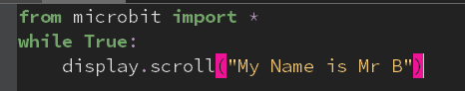

A. 1

B. 0

C. 10

D. Forever

ANSWER: D

What is ‘functional programming’?

A. Where the outcome of a function depends only on the arguments that are passed to it

B. Where actions control the flow of the program

C. Where code always runs in order, step by step

D. Where code is written using only block programming

ANSWER: A

The code below creates a function. What is the name of the function?

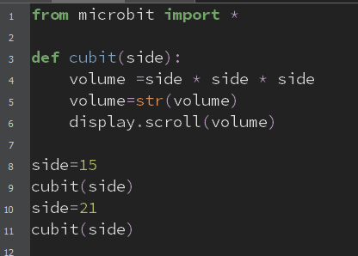

A. def

B. cubit

C. side

D. volume

ANSWER: B

Some devices have hardware built which means that if you lose them you can check where they have been left via a website. Which sensor does this location feature use?

A. Compass

B. Ultrasonic

C. GPS

D. None of the above

ANSWER: C

The technology adoption cycle can be used to determine when different groups are likely to purchase a product. Lola always buys a new phone on the day that it is launched. Which group does she belong to?

A. Early adopters

B. Early majority

C. Late majority

D. Laggards

ANSWER: A

The technology lifecycle defines different stages in the life of a product. Which is the final stage of the lifecycle?

A. Growth

B. Research and Development

C. Maturity

D. Decline

ANSWER: D

The code below is used to measure the distance from an object. Which sensor would you use with this code?

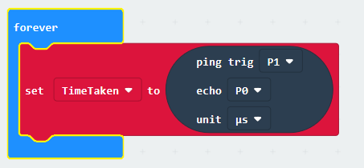

A. Accelerometer

B. Distance

C. Ultrasonic

D. Light

ANSWER: C

Many autonomous systems use machine learning. What is machine learning?

A. When a human teaches a robot to do something

B. When you program a machine to do something

C. A type of machine which a human learns from

D. When a machine learns for itself and adapts to different situations

ANSWER: D

SWOT analysis can be used to analyse the potential success of a product. What does O stand for in SWOT analysis?

A. Output

B. Overview

C. Organisation

D. Opportunities

ANSWER: D

What is a stakeholder?

A. Someone who owns the business

B. Someone who holds a stick

C. Anyone who has any interest in the business

D. Someone who owns shares in the business

ANSWER: C

Which of the following contains an embedded system?

A. Oven

B. Smart lightbulb

C. Smart watch

D. All of the above

ANSWER: D

In the Python code below, what is microbit an example of?



A. Variable

B. Constant

C. Function

D. Library

ANSWER: D